CGT270 Midterms Part II

Data Visualization Challenge

Student:

Senny Huang

Professor

Dr. Vetria Byrd

TA

Subia Ansari

Course:

CGT 27000 Data Visualization

Term:

Fall 2021

Contents

Halloween Visualization 3

Data Description 3

Location of home 4

Example 4

The Assignment 5

Data Visualization Process 6

Acquire 6

The Data 6

Parse & Mine 7

Represent 8

Filter 10

Critique 11

Refine 12

What’s the story? 14

# Halloween Visualization

This in-class assignment is to create data visualizations using data collected about trick-or-treaters in Cincinnati, OH. **You should create two (2) visualizations**, this can be a collection of charts or a dashboard, whatever is necessary to the story or analysis that is shown in your visualizations. Make sure you **READ and FOLLOW ALL Instructions**. The goal is to demonstrate your understanding of the data visualization process.

# Data Description

|  |  |  |
| --- | --- | --- |
| The data is available in two formats   * Halloween data for Excel 2020 is a crosstab table which is ideal for creating visualizations in Excel. Numbers in the data file for Excel are **cumulative**. * Halloween data for Tableau 2020” is unpivoted which is ideal for creating visualizations in Tableau. Numbers in the data file for Tableau are **not cumulative**. * The data has been collected since 2008. * The numbers in the table are cumulative totals of the number of trick-or-treaters who visited one house each year. * The numbers are measured at 30-minute intervals, except for the last 15-minute interval. |  | * The trick-or-treat count was recorded in 30-minute intervals except for the last 15-minute interval. * The night of trick-or-treating has always been on October 31st each year (some neighborhoods change the night of trick-or-treating). * Official tick or treat hours are from 6 PM to 8 PM, but there are often “stragglers” past 8 PM that are not turned away. These stragglers are counted in the 8PM – 8:15 PM time slot. There has never been a trick-or-treater past 8:15 PM. * The type of candy did not vary year-by-year. It is always a general mix of candy purchased in bulk variety bags. |

## Location of home

Neighborhood: East Walnut Hills/Evanston

City, State: Cincinnati, Ohio

Zip code: 45207

Being a corner house on the neighborhood border likely increases the number of trick-or-treaters.

## Example

Here’ an example of how previous Halloween data have been visualized. Be creative!

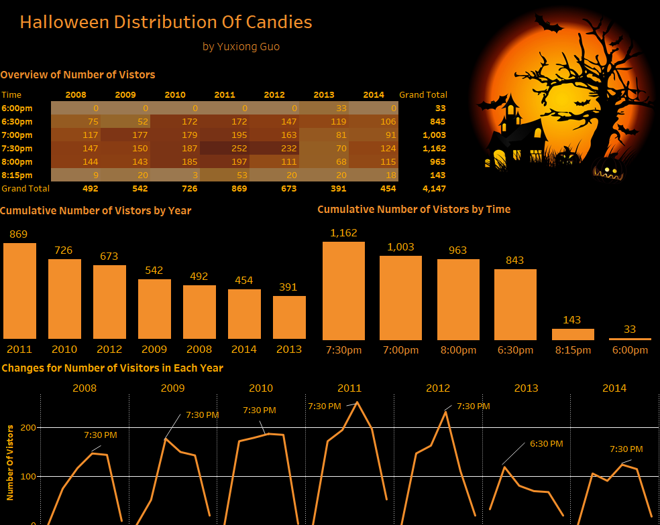

# The Assignment

There are multiple parts to this assignment. Make sure you read the entire assignment before starting.

Determine a story or goal to support the two (2) visualizations you will create using the Halloween data provided. Your two visualization MUST be different chart types. **This means DO NOT create two bar charts or two-line charts or two of the same chart types!** Challenge yourself. This is your time to show what you know.

Examples (these are examples):

* Homeowner dashboard summarizing Halloween
* Forecast future trick-or-treaters or estimate future candy needed
* Explore variation of the number of trick-or-treaters year by year
* **Be creative and think of other things you could do**

# Data Visualization Process

Show your understanding of the data visualization process.

# Acquire

## The Data

|  |  |  |  |  |  |  |
| --- | --- | --- | --- | --- | --- | --- |
| **Year** | **6pm** | **6:30pm** | **7pm** | **7:30pm** | **8pm** | **Total (8:15pm)** |
| 2020 | 11 | 55 | 107 | 155 | 211 | 219 |
| 2019 | 0 | 117 | 262 | 406 | 483 | 523 |
| 2018 | 18 | 191 | 342 | 497 | 589 | 600 |
| 2017 | 41 | 190 | 357 | 549 | 710 | 776 |
| 2016 | 22 | 160 | 386 | 612 | 759 | 822 |
| 2015 | 13 | 148 | 336 | 523 | 667 | 747 |
| 2014 | 0 | 106 | 197 | 321 | 436 | 454 |
| 2013 | 33 | 152 | 233 | 303 | 371 | 391 |
| 2012 | 0 | 147 | 310 | 542 | 653 | 673 |
| 2011 | 0 | 172 | 367 | 619 | 816 | 869 |
| 2010 | 0 | 172 | 351 | 538 | 723 | 726 |
| 2009 | 0 | 52 | 229 | 379 | 522 | 542 |
| 2008 | 0 | 75 | 192 | 339 | 483 | 492 |

Excel and Tableau versions of the data are provided in Brightspace. **Choose one (1) to work with**.

* HalloweenExcel
* HalloweenTableau

# Parse & Mine

Use this page to provide a parsing of the data. For quantitative fields list some basic statistical procedures that can be performed in the space below. To be clear, you are to list the procedure (you are not required to actually do any calculations here).

Use the Tab key to add more rows to the table below.

|  |  |  |
| --- | --- | --- |
| **Variable** | **Data type** | **Statistical Method**  **(where applicable)** |
| Date | Interval - Date |  |
| Date and Time | Interval - Date |  |
| Count | Nominal - Number | Min: 0 Max: 252 |
| Day of the Week | Interval - String |  |
| Time | Interval - String |  |

# Represent

Remove this text before submission: You can use any visualization tool you are most comfortable with. Replace the image below with your first visualization.

How to replace this figure: Right-click on the figure below, select Change Picture 🡪 From a File. Locate your figure.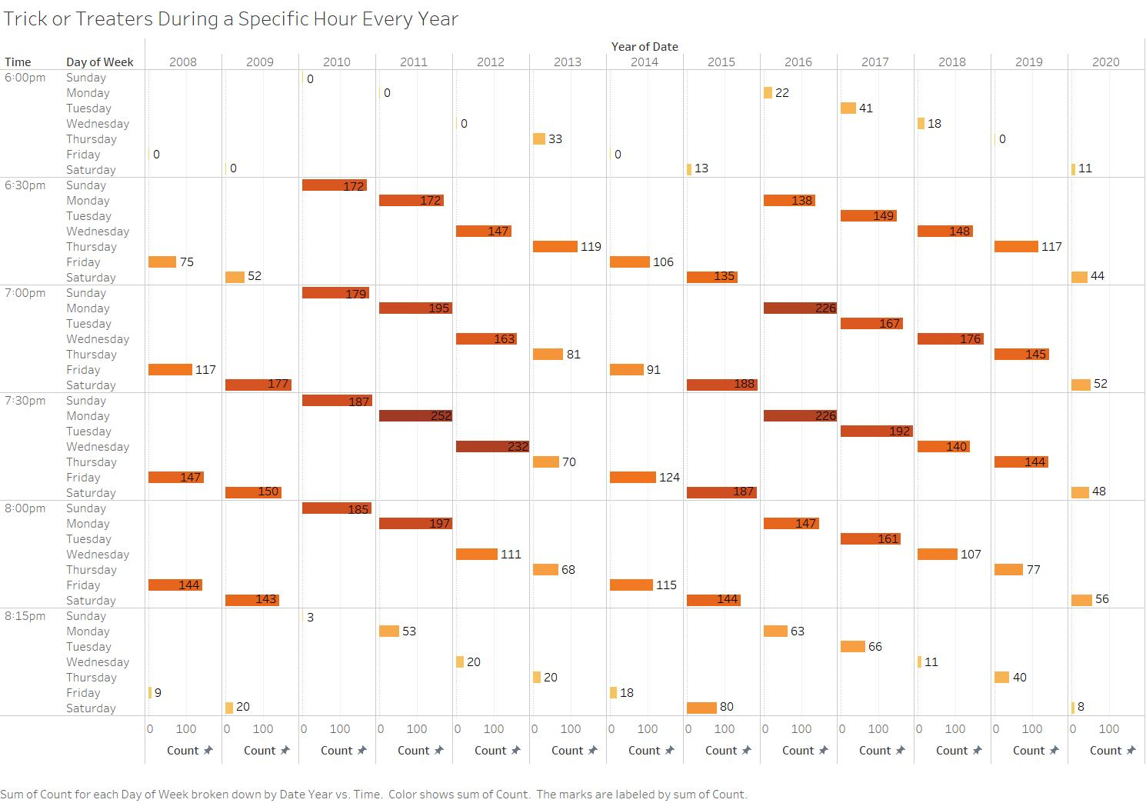 Figure 1. Sum of Count for each Day of Week broken down by Date Year vs Time. Color shows sum of the total Trick or Treaters for that specific year, day, and hour. The marks are labeled by the sum of count.

<Remove this text before submitting your work: replace the image below with your second visualization.>

How to replace this figure: Right-click on the figure below, select Change Picture 🡪 From a File. Locate your figure.

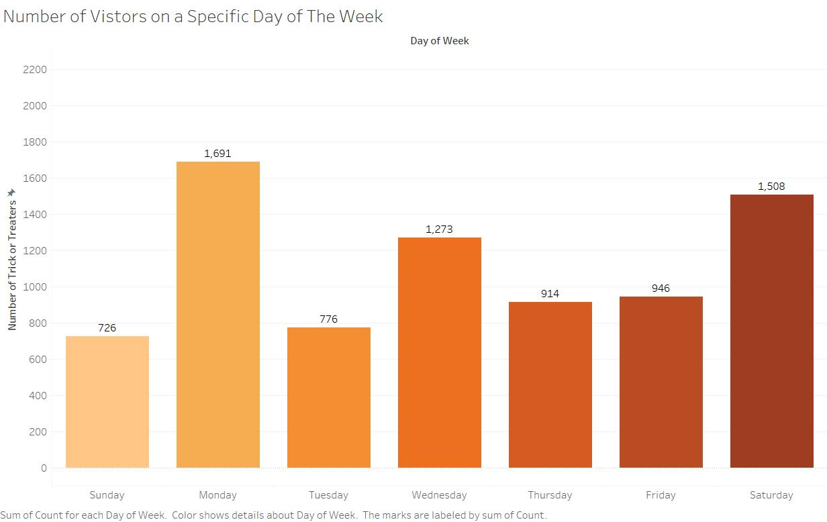 Figure 2. Number of Trick or Treaters on a specific day of the week. The days are labeled by color, and the number labels show how many Trick or Treaters were counted that day.

**Helpful Tip: Utilize the space that you have. Do NOT create a tiny visualization that is unreadable. Remember, the purpose of visualization is insight, but all insight is lost if it cannot be seen.**

# Filter

In this page show the data you used to create your visualizations.

**Figure 1**

Year from Date

Day of the Week

Time

Count of Trick or Treaters

**Figure 2**

Day of the Week

Count of Trick or Treaters

# Critique

Rate your visualizations (Figure 1 and Figure 2) using the link below

<https://stephanieevergreen.com/rate-your-visualization/>

**Figure 1 Rating**

**Figure 2 Rating**

# Refine

In this part of the visualization challenge, you should identify one or more characteristics of the visualizations you created (Figure 1 and Figure 2) and update the figures. Include an updated version of each Figure below. In the figure caption, state what changes were made.

Replace the picture with your visualization, remove this text before submission.

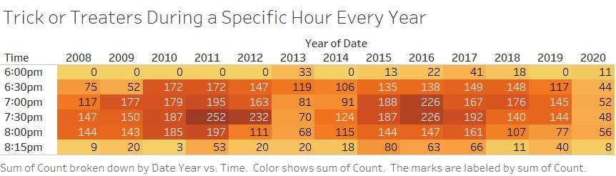

Figure 1 Refined. Changed the data in a way where it was easier to read compared to the original which had very small text. I also simplified the data by removing the day of the week as that information was not needed specifically.

Replace the picture with your visualization, remove this text before submission.

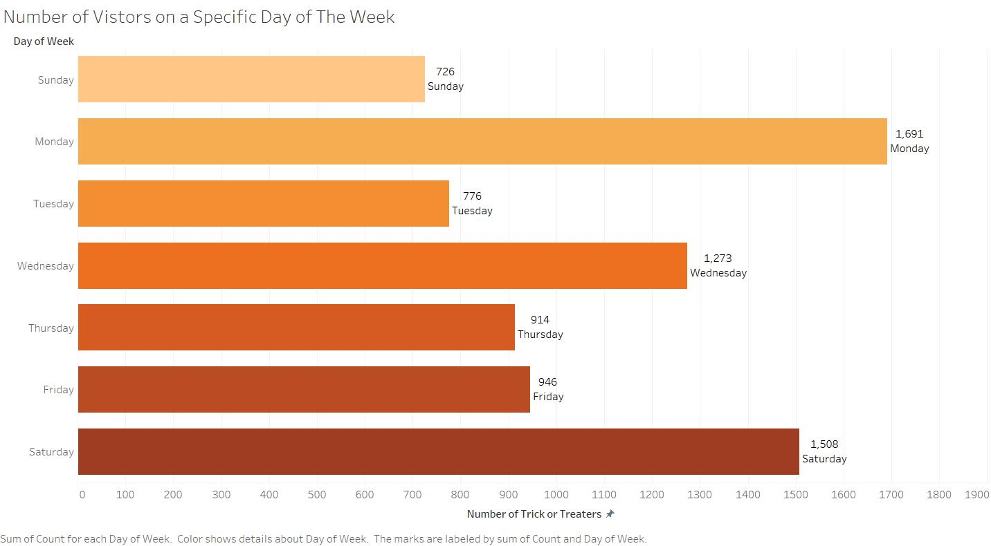

Figure 2 I reversed the Axis so that all of the text could be viewed horizontally. I also made the colors go in order of the day of the week, and I added labels for each value regarding the day of the week the value was associated with.

# What’s the story?

**Replace the text on this page with your story**. The story should be no more than one-page **If you go over the page limit, your story will NOT be read (-5 pts)**. Single space Calibri Light (Body) font, font size 13. This is a very simple data set. There are only a few years of data broken down into 4 half-hour time blocks with cumulative totals.

Using complete sentences, answer the following questions:

1. Throughout my visualizations, the story that I tried to tell through Figure 1 was the number of Trick or Treaters at a specific hour each year (while also keeping track of Day of the Week) while my Figure 2 was to show the number of Trick or Treaters on a specific day of the week. My refined data allowed the viewer to see the data better, for example, on my Figure 1, it was too small and showed too much data. I fixed this by removing the day of the week and changing the format of the data entirely. For the revised version of Figure 2, I went ahead and reversed the axis and added labels. I made sure all the text was horizontal throughout the entire process. Overall, the visualizations I created tell the viewer not only the number of visitors per time frame during Halloween, but it also tells the viewer when the most popular times are for trick or treating.
2. Who is your audience? (Use complete sentences)

People who are interested in the statistics for Trick or Treating

1. List 3 assumptions you made while implementing the data visualization process?
   1. The person viewing it understands English and can read the visualization.
   2. The person understands Halloween and how Trick or Treating works.
   3. This person is interested in learning more about the statistics for Trick or Treating.

Points will be taken off for incomplete sentences.

Bonus points for REALLY GOOD stories!

**Checklist of what to submit:**

* **Save this file as LastnameFirstInitial_CGT270Fall2021_MidtermPartII.pdf**
* **Only submit one (1) file. All of your work should be contained in this file.**
* **Failure to follow these instructions will result in your work NOT being graded.**

**General Deductions (others made accordingly)**

* **No name on the first page of the document: -5 pts**
* **Altered template: -10 pts**
* **No figures included: -15 pts for each missing figure**
* **No figure captions: -10 pts for each missing caption**
* **Zip file submitted: See Checklist of what to submit (-80 pts)**
* **Late submissions: Will NOT be graded (-80 pts)**
* **Provided a link to visualizations instead of providing screenshot of the visualization: this will be treated as no figure, no figure caption (-25 pts)**
* **Failure to follow data visualization best practices (data visualization checklist): deductions made appropriately.**

**Keep in mind: one (1) second after the submission deadline is considered late.**



Byrd Data Visualization Lab